**Text Message Examples**

**Use these examples to inspire your own text messages for fundraising.   
Feel free to edit and choose what you’d most like to say.   
Your words are more powerful than any we could give you!**

1. **Potential Donor asks Venmo information.**

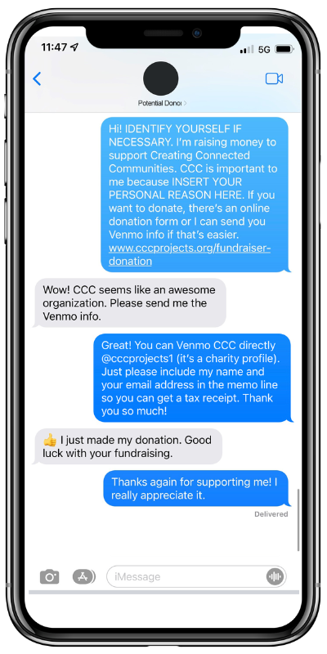

1. **Potential Donor asks for more information about CCC.**

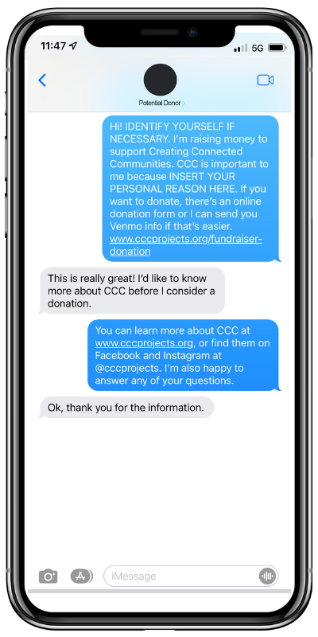

1. **You don’t hear back after your initial texts and need to follow up.**

